http://demo.guru99.com/test/drag_drop.html

Before Drag and Drop

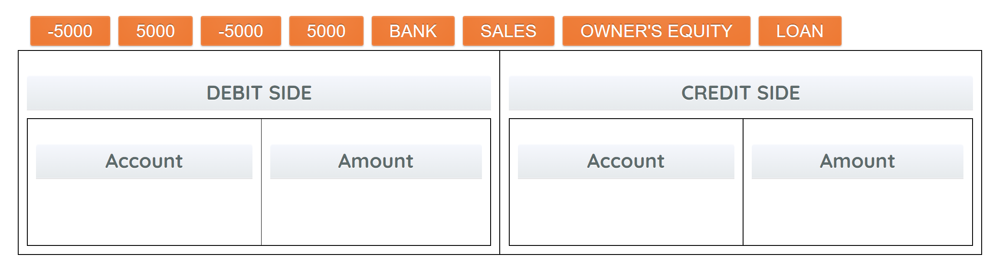

After Drag and Drop

